Before going any further:
- Determine if the taxpayer received a total $500 or more Non-Business Residential Property Credit from 2006 to 2018. If they did STOP. This credit has a lifetime limitation of $500.
- Determine if the qualified improvements were made for the taxpayer’s main home located in the United States
- Determine if the improvements were related to the construction of this main home. You can’t claim any expenses for qualified improvements that are related to the construction of the home even if the improvement is installed after you have moved into the home. You may only include expenses for qualified improvements for an existing home or for the addition or renovation to the existing home.
- Determine that the products qualify for the Non-Business Residential Property Credit. A document from the manufacturer certifying that their product meets the standard is preferred. See page 5 of this document for more information

Recent legislation has made the nonbusiness energy property credit available for both 2018 and 2019. The credit had expired at the end of 2017. You may claim the nonbusiness energy property credit on your 2019 return if you meet the 2019 criteria. You may also now claim the credit for 2018 if you meet the criteria for that year, but most taxpayers will need to file their 2018 Form 5695 with an amended return (Form 1040-X) to claim the credit for 2018.
Part I of Form 5695, Residential Energy Efficient Property Credit, is available for taxpayers who purchased qualified residential alternative energy equipment, such as solar hot water heaters, geothermal heat pumps and wind turbines. This part of the form is Out of Scope. Taxpayers that have these expenses should be referred to a professional tax preparer.

Part II of the form 5695 is the Non-Business Residential Property Credit. It is in scope. Key points of this credit are:
- A total combined credit limit of $500 ($200 limit for windows) for all tax years after 2005.
- The maximum credit for residential energy property costs is $50 for any advanced main air circulating fan; $150 for any qualified natural gas, propane, or oil furnace, or hot water boiler; and $300 for any item of energy-efficient building property. Any of the following that meet the required efficiency rating may qualify as energy-efficient building property.
  - Electric heat pump water heater
  - Electric heat pump
  - Central air conditioner
  - Natural gas, propane, or oil water heater
  - A stove that uses the burning of biomass fuel to heat your home or heat water for your home.
- The credit applies to:
  - Qualified energy efficiency improvements such as adding insulation, energy-efficient exterior windows and doors, and qualifying metal or asphalt roofs. (doesn’t include labor costs for onsite preparation, assembly or installation)
  - Qualified residential energy property improvements such as energy-efficient heating and air conditioning systems (includes labor costs for onsite preparation, assembly, original installation)
- The improvements must be made to the taxpayer’s main home located in the United States (must be existing home).
- Qualifying improvements must be placed into service by the taxpayer during the tax year.
- Expenditures which are made from subsidized energy financing can’t be used to figure the credit.
- The credit is taken on Part II, Form 5695.

Note: Not all ENERGY STAR products qualify for a tax credit. Since 2016, exterior doors, exterior windows, and skylights are only eligible for the nonbusiness energy property credit if they meet or exceed the specific requirements of the version 6.0 Energy Star program. For detailed information about qualifying improvements, visit the U.S. Department of Energy’s EnergyStar website.

Manufacturers must certify that their products meet new standards and they must provide a written statement to the taxpayer such as with the product packaging or in a printable format on the manufacturer’s website. Taxpayers should keep a copy of the manufacturer’s certification statement and receipts with their other important tax records.

References:
- IRS Publication 4012-page Ext-7
- IRS Instructions for form 5695
- Energy Star Web Site
https://www.energystar.gov/about/federal_tax_credits/non_business_energy_property_tax_credits

TaxSlayer Entry
Step1: Enter 5695 in the TaxSlayer search box.
Step 2: Check the box “Check here if the energy efficiency improvements or residential energy property costs were made to your main home located in the United States”.
Step 3: The box “Check here if any of these improvements were related to the construction of this main home” should not be checked, “
Step 4: Select “Begin” for “Non-Business Energy Property”
Step 5: Enter the address of the Main Home. You can select “Use my main address” if applicable.
Step 6: Enter the dollar amount of the insulation material or systems
Step 7: Enter the dollar amount of the exterior doors that meet or exceed the version 6.0 Energy Star program.
Step 8: Enter the dollar amount of the exterior windows and skylights that meet or exceed the version 6.0 Energy Star program.
Step 9: Enter any prior amount claimed for exterior windows from 2006 to 2016. If that amount is $2,000 or greater, the lifetime credit for windows has been exceeded.
Step 10: Enter the dollar amount of the Metal or asphalt roof with appropriate pigmented coatings or cooling granules that meet the Energy Star program requirements and is specifically and primarily designed to reduce heat gain in your home
Note: The dollar amounts entered in Steps 6-10 should not include any amounts paid for onsite preparation, assembly, or original installation of the components.
Step 11: Enter the installed dollar amount of the Energy Efficient building property. The maximum amount is $300. They include:
  - Electric heat pump water heater
  - Electric air source heat pump
  - Central air conditioner
Natural gas, propane, or oil water heater
  - A stove that uses the burning of biomass fuel to heat your home or heat water for your home.
Step 12: Enter the installed dollar amount for a natural gas, propane or oil furnace or hot water boiler. The maximum amount is $150.
Step 13: Enter the installed dollar amount of the Advanced main air circulating fan used in a natural gas, propane, or oil furnace. The maximum amount is $50.
Step 14: If any non-business residential property tax credit was taken for any year from 2006 through 2018, the amount must be entered in the appropriate year. If the total is $500 or greater the lifetime limit has been exceeded.
Step 15: Continue
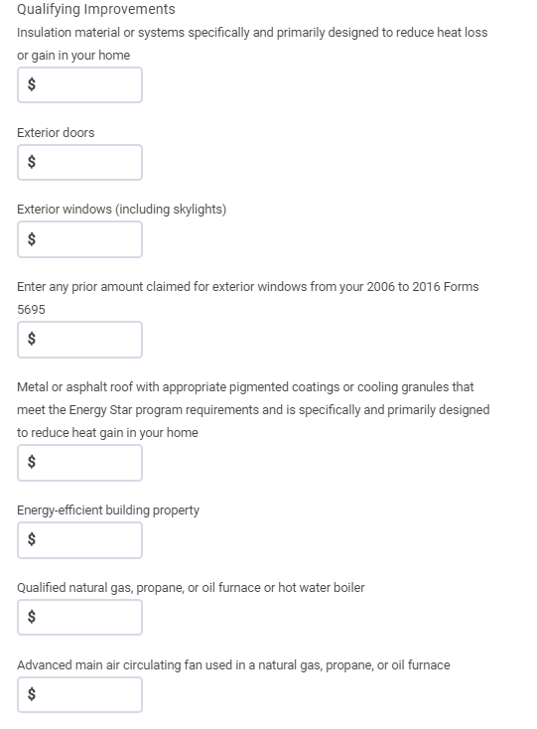

Step 6

Step 13
Step 12
Step 11
Step 10
Step 9
Step 8
Step 7

- W

For the purpose of taking this credit, you can rely on a manufacturer’s certification in writing that a building envelope component or qualified energy property meets the eligibility requirement for this credit. The following are some guidelines that can be used:
- Windows, Skylights and Doors
  - Meet or exceed the version 6.0 Energy Star program
  - https://www.energystar.gov/products/building_products/residential_windows_doors_and_skylights/key_product_criteria
- Electric heat pump water heater
  - Most Energy Star certified water heaters meet the requirement
  - A uniform Energy Factor of a least 2.2
- Electric air source heat pump
  - Heat pumps that are Energy Star meet the requirement
  - Split System: HSPF >= 8.5, EER >= 12.5, SEER >= 15
  - Packaged System: HSPF >=8, EER >= 12, SEER >=14
- Central air conditioner
  - Systems recognized as Energy Star Most Efficient meet the requirement
  - Split System: SEER >=16, EER >=13
  - Packaged System: SEER >=14, EER >=12
- Natural gas, propane or oil hot water heater
  - Certain Energy Star certified gas water heaters meet the requirement
  - Energy factor >=0.82 or a thermal efficiency of at least 90%
- Natural gas, propane, or oil furnace or hot water boiler
  - Gas furnaces that are Energy Star certified meet the requirement
  - AFUE>= 95
- Advanced main circulating fan
  - Must use no more than 2% of the furnace’s total energy
- Biomass stove
  - Thermal efficiency rating of at least 75%

- Note: Reference for the above information is from the Energy Star Web Site: https://www.energystar.gov/about/federal_tax_credits/non_business_energy_property_tax_credits

